
FACILITY RENTAL AGREEMENT & POLICIES
102 NE Street • Edna, Texas 77957
Office: 361-433-5050 • Emergency Only: 386-301-9996 • info@getmygp.com

Welcome
Thank you for choosing The Gathering Place. This agreement is designed to provide a smooth rental experience while protecting both you and our facility.

Renter Information
Renter Name
Phone
Email
Address
City/State/Zip

Event Information
Event Date
Rental Time
Event Type
Estimated Guests
Maximum Occupancy | 50 Guests

Select Your Rental Package
☐ SPACE ONLY RENTAL PACKAGE
Reserved Facility Space • Tables & Chairs • Restroom Access
☐ FULL EXPERIENCE RENTAL PACKAGE
Everything above plus unlimited access to available games and amenities.

Amenities Included
Five Smart TVs • Pool Table • Air Hockey • Skee-Ball • Electronic Darts • Xbox • Karaoke • Interactive Golf • Basketball Arcade • Ping Pong • Cornhole • Foosball • Board Games • Outdoor Activities

Rental Rates
Rental Time | Weekday | Weekend
2 Hours | $75 | $99
4 Hours | $125 | $175
6 Hours | $175 | $225

Full Experience | Weekday | Weekend
2 Hours | $150 | $175
4 Hours | $200 | $250
6 Hours | $250 | $300

Optional Add-Ons
Add-On | Price
Early Access (30 min) | $25
Additional 30 Minutes | $40
Full Cleanup Service | $75

BOOKING SUMMARY
Rental Package | ☐ Space Only ☐ Full Experience
Rental Fee | $____________
Add-Ons | $____________
Reservation Payment | $_____50.00_____
Security Deposit | ☐ $100 ☐ $150 $________
Balance Due | $____________

IMPORTANT BOOKING INFORMATION
A $50.00 non-refundable Reservation Payment is required to reserve and secure your event date. It is applied toward your total rental balance.

PAYMENT POLICIES

Reservation Payment
• $50.00 non-refundable Reservation Payment required.
• Applied toward total rental.

Security Deposit
• Space Only Rental Package: $100
• Full Experience Rental Package: $150

Payment Schedule
• Reservation Payment: At booking
• Security Deposit: 21 days before event
• Remaining Balance: 21 days before event

Accepted Payment Methods
• Cash App
• Zelle
• Other methods (check, cashier check, money order, PayPal etc.) with management approval.

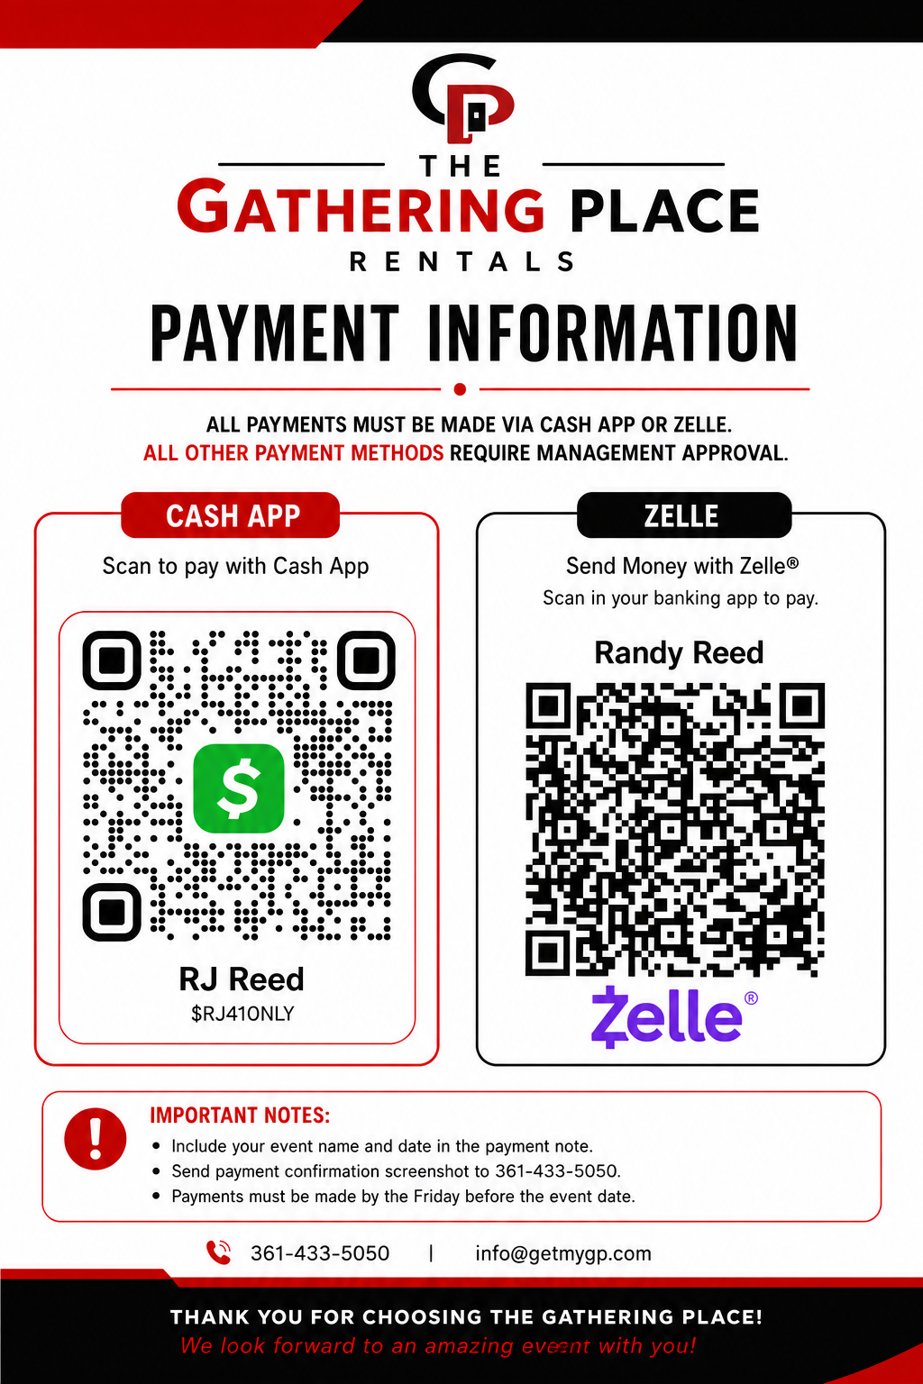v

Late or Non-Payment
Failure to pay by the due date may result in cancellation, forfeiture of the Reservation Payment, and loss of the reservation.

Section 1

FACILITY RULES & GUEST RESPONSIBILITIES
The Gathering Place is committed to providing a clean, safe, and enjoyable environment for everyone. The Renter is responsible for ensuring that all guests, invitees, vendors, entertainers, and service providers comply with this Facility Rental Agreement & Policies throughout the event.

GENERAL FACILITY RULES
▪ Maximum occupancy is Fifty (50) Guests unless approved in writing by the Facility Representative.
▪ The Renter or designated responsible adult must remain on-site throughout the event.
▪ Children must be supervised by a responsible adult at all times.
▪ Guests may use only those areas and amenities included in the selected Rental Package.
▪ Furniture, games, televisions, and equipment may not be moved without prior approval from the Facility Representative.
▪ Please help keep the Facility clean and organized throughout your event.
▪ The Facility Representative may require the Renter or any guest engaging in unsafe, disruptive, destructive, threatening, or inappropriate behavior to immediately stop the activity or leave the premises. Failure to comply may result in suspension or termination of the event without refund.

PROHIBITED ITEMS & ACTIVITIES
▪ No smoking or vaping inside the Facility.
▪ No illegal drugs, illegal activity, or disorderly conduct.
▪ No weapons unless otherwise authorized by applicable law.
▪ No fireworks, sparklers, candles, or open flames.
▪ No glitter, confetti, rice, birdseed, or similar decorations.
▪ No nails, screws, staples, tacks, adhesives, etc. that may damage walls, ceilings, floors, furniture, or equipment.
▪ No standing, climbing, or jumping on tables, chairs, games, or furniture.
▪ No fighting, horseplay, harassment, intimidation, abusive language, threatening behavior, or any unsafe conduct that may endanger others, disrupt the event, or damage the Facility.

FOOD & BEVERAGES
▪ Outside food and beverages are welcome.
▪ Please dispose of all food, beverages, and trash properly.
▪ Clean spills promptly to help prevent accidents.
▪ Alcohol is permitted only with prior written approval from the Facility Representative and must comply with The Gathering Place Alcohol Policy.

GAMES & EQUIPMENT
▪ Please use all games, televisions, furniture, and equipment responsibly and only for their intended purpose.
▪ Immediately report any damaged, malfunctioning, or unsafe equipment, conditions, or hazards to the Facility Representative.
▪ Do not unplug, relocate, alter, tamper with, misuse, or attempt to repair any televisions, arcade games, gaming systems, electronics, furniture, or other Facility equipment without prior approval from the Facility Representative.
▪ Equipment and amenities are provided for the enjoyment of all guests and should be used safely and responsibly.
▪ The Gathering Place reserves the right to temporarily remove, restrict access to, repair, replace, or discontinue the use of any game, television, amenity, attraction, furniture, or other Facility equipment due to maintenance, repairs, safety concerns, weather conditions, operational needs, or other unforeseen circumstances. Such temporary unavailability shall not constitute a breach of this Agreement and shall not entitle the Renter to a refund, credit, discount, reduction of the Rental Fee, or any other compensation.
▪ The Renter is responsible for ensuring that all guests use Facility equipment safely and responsibly. Any damage resulting from misuse, negligence, reckless behavior, intentional acts, or failure to follow instructions may result in deductions from the Security Deposit. If damages exceed the Security Deposit, the Renter agrees to pay the remaining balance in accordance with this Agreement.

RESPECT FOR OTHERS
▪ Please respect neighboring businesses and surrounding property.
▪ Excessive noise, disruptive conduct, or inappropriate behavior may result in immediate suspension or termination of the event without refund.
▪ Guests must comply with all instructions provided by the Facility Representative.

RENTER RESPONSIBILITY & ACKNOWLEDGEMENT
The Renter accepts full responsibility for the conduct and actions of all guests, invitees, children, vendors, entertainers, caterers, decorators, photographers, DJs, and other service providers attending the event. The Renter agrees to ensure all guests comply with this Facility Rental Agreement & Policies, promptly report any damage, accidents, or unsafe conditions to the Facility Representative, accept financial responsibility for all damages, excessive cleaning, missing items, policy violations, or other costs resulting from the event or the actions of the Renter's guests, and cooperate with the Facility Representative before, during, and after the event, including the pre-event and post-event walkthrough.
FACILITY REPRESENTATIVE AUTHORITY
The Facility Representative is authorized to interpret and enforce this Facility Rental Agreement & Policies during the event. The Renter agrees to comply with all reasonable instructions issued by the Facility Representative regarding safety, occupancy limits, protection of Facility property, compliance with these policies, and the orderly operation of the event. Failure to comply may result in suspension or termination of the event without refund and may result in deductions from the Security Deposit or additional charges as provided in this Agreement.
Renter Initials: ____________________ Section 1 of 3 Version 2.0 • Revised July 2026

Section 2

FINANCIAL RESPONSIBILITIES & EVENT POLICIES

SECURITY DEPOSIT
A Security Deposit is required for every Rental Package and is separate from the Reservation Payment. The Security Deposit helps cover damages, excessive cleaning, missing items, policy violations, or other expenses resulting from the event. Any unused portion will be refunded following inspection of the Facility and verification by the Facility Representative that all terms of this Agreement have been satisfied. Security Deposit refunds are generally processed within Five (5) to Seven (7) Business Days after the event, provided no additional inspection, repair estimates, or damage assessments are required.
Rental Package | Security Deposit
Space Only Rental Package | $100
Full Experience Rental Package | $150

SECURITY DEPOSIT DEDUCTIONS
▪ Damage to the building, walls, windows, doors, ceilings, floors, or restrooms.
▪ Damage to tables, chairs, furniture, televisions, games, electronics, or equipment.
▪ Missing furniture, equipment, or Facility property.
▪ Excessive cleaning beyond normal use.
▪ Failure to complete required cleanup.
▪ Trash removal or disposal of items left behind.
▪ Damage caused by decorations, tape, adhesives, nails, screws, staples, etc.
▪ Unauthorized movement or misuse of equipment.
▪ Plumbing or restroom damage caused by misuse.
▪ Failure to secure and lock the building after the event.
▪ Violations of this Facility Rental Agreement & Policies resulting in additional expenses.
If damages, cleaning charges, missing items, or other expenses exceed the amount of the Security Deposit, the Renter agrees to pay the remaining balance within Ten (10) Business Days after receiving written notice and an itemized invoice from the Facility Representative. Failure to remit payment may result in collection efforts or any other legal remedies permitted by law.

CANCELLATION & REFUND POLICY

22 or More Days Before Your Event
- The Reservation Payment is non-refundable.
- Any Security Deposit and rental payments will be refunded.
21 Days or Less Before Your Event
- The Reservation Payment is non-refundable.
- Rental payments are non-refundable.
- Security Deposits are non-refundable. Your reserved event date will be forfeited.

RESCHEDULING POLICY
▪ Requests to reschedule must be made before the original event date.
▪ Rescheduling is subject to Facility availability and approval by the Facility Representative.
▪ If approved, payments previously received may be applied toward the new event date.
▪ Rescheduling is permitted One (1) Time Per Reservation unless otherwise approved in writing by management.

EVENT SUSPENSION OR TERMINATION
The Gathering Place reserves the right to immediately suspend or terminate an event without refund if any of the following occur:
▪ Illegal activity.
▪ Violence, threats, disorderly conduct, or fighting.
▪ Damage to the Facility or equipment.
▪ Violation of the maximum occupancy limit.
▪ Failure to comply with this Facility Rental Agreement & Policies.
▪ Any situation the Facility Representative reasonably determines places people, property, or the Facility at risk.

Renter Initials: ____________________ Section 2 of 3 Version 2.0 • Revised July 2026

Section 3

GENERAL TERMS & CONDITIONS

LIABILITY
The Gathering Place, its owners, officers, employees, volunteers, agents, and the Facility Representative shall not be liable for any injury, illness, accident, death, loss, theft, or damage to persons or personal property arising from or related to the use of the Facility, except to the extent caused by gross negligence or willful misconduct as provided by applicable law. The Renter accepts full responsibility for the conduct and safety of all guests and acknowledges that use of the Facility, its amenities, equipment, furnishings, and surrounding property is at the Renter's and guests' own risk.

PERSONAL PROPERTY
The Gathering Place is not responsible for lost, stolen, or damaged personal property belonging to the Renter, guests, vendors, entertainers, caterers, decorators, photographers, DJs, or other service providers. Any personal property left behind after an event may be discarded or otherwise disposed of if not claimed within Seven (7) Days, unless prior arrangements have been approved by the Facility Representative.

EMERGENCIES (Office: 361-433-5050/After Hours 386-301-9996)
In the event of an emergency, the Renter shall immediately notify the Facility Representative and contact emergency services by calling 911 when appropriate. The Renter agrees to cooperate fully with emergency responders and the Facility Representative, follow all instructions provided during the emergency, and take reasonable actions necessary to protect the safety of all persons and the Facility.

SEVERABILITY
If any provision of this Facility Rental Agreement & Policies is determined to be invalid or unenforceable by a court of competent jurisdiction, the remaining provisions shall remain in full force and effect and continue to be binding upon all parties.

GOVERNING LAW
This Facility Rental Agreement & Policies shall be governed by and interpreted in accordance with the laws of the State of Texas. Any legal action arising out of or relating to this Agreement shall be brought in a court of competent jurisdiction located in Jackson County, Texas, unless otherwise required by applicable law.

ENTIRE AGREEMENT
This Facility Rental Agreement & Policies constitutes the complete and entire agreement between The Gathering Place and the Renter concerning the rental and use of the Facility and supersedes all prior discussions, negotiations, representations, promises, or agreements, whether oral or written. No amendment, waiver, or modification shall be valid unless made in writing and signed by both parties. The Renter further acknowledges that no verbal statements, promises, or representations not contained within this written Agreement shall modify or supersede its terms unless approved in writing by management of The Gathering Place.

AGREEMENT ACKNOWLEDGEMENT
By signing this Agreement, the Renter acknowledges that he or she has carefully read, understands, and voluntarily agrees to comply with all terms, conditions, policies, responsibilities, financial obligations, and requirements contained within this Facility Rental Agreement & Policies.

Renter Initials: ____________________ Section 3 of 3 Version 2.0 • Revised July 2026

Section 4

EVENT COMPLETION & FINAL ACCEPTANCE

BOOKING SUMMARY
Description | Amount
Rental Package | ☐ Space Only Rental Package ☐ Full Experience Rental Package
Rental Fee | $________________________
Add-Ons | $________________________
Reservation Payment | $50.00
Security Deposit Paid | ☐ $100 ☐ $150 $__________________
Total Rental Amount | $________________________
Amount Paid | $________________________
Remaining Balance | $________________________

FINAL ACKNOWLEDGEMENT
By signing below, the Renter acknowledges that they have read, understood, and agree to comply with all terms and conditions contained in this Facility Rental Agreement & Policies. The Renter accepts responsibility for the conduct of all guests, all financial obligations outlined in this Agreement, and any additional charges due under its terms. The Renter further acknowledges that no verbal statements, promises, or representations shall modify or supersede this Agreement unless approved in writing by the management of The Gathering Place. The Renter has had the opportunity to ask questions regarding this Agreement and the Facility before signing. By signing below, the Renter accepts this Agreement in its entirety.

RENTER INFORMATION

Printed Name: _______________________________________________

Cell Phone: _________________________________________________

Email Address: ______________________________________________

Mailing Address: ____________________________________________ City: _______________ State: ______ Zip: __________

Emergency Contact: __________________________________________

Emergency Contact Phone: ____________________________________

Contact Email: ____________________________________

Signature: _________________________________________________ Date: ______________________

THE GATHERING PLACE
Facility Representative: _________________________________
Signature: _____________________________________________
Date: ______________________

Thank You for Choosing the Gathering Place!

Take a picture of the contact numbers below so they are readily available.
The Gathering Place
Powered by Love Sports Academy
102 NE Street • Edna, Texas 77957
Office: 361-433-5050 / Emergency After Hours 386-301-9996
We sincerely appreciate the opportunity to be part of your special event. Thank you for helping us maintain a clean, safe, and welcoming place where families, friends, churches, teams, organizations, and our community can gather, celebrate, and create lasting memories together.
We hope your event is everything you imagined and look forward to welcoming you back again soon!

Renter Initials: ____________________ Section 4 of 4 Version 2.0 • Revised July 2026

